Using house teleporters

Using a house teleporter kit, you may place a house teleporter in any house you own. The kit allows you to place a primary (origin) and secondary (destination) teleporter. The primary and secondary teleporters do not need to be in the same house but you must be the owner of both houses. Check with your shard’s staff or its documentation to find out where you can obtain a house teleporter kit.

Let’s walk through the simple process of placing teleporters. When you double-click a house teleporter kit you will receive a Graphical User Menu Pop-up (GUMP). The instructions are in the gump. So I will not cover them in this document.

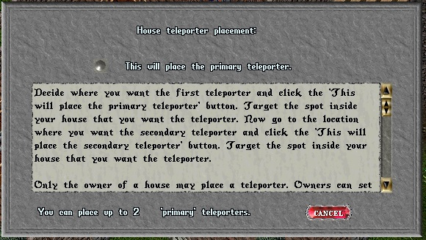

Once you click the button you will receive a target cursor. Assuming you targeted a location inside the boundaries of your house, you will receive the gump to place the secondary teleporter.

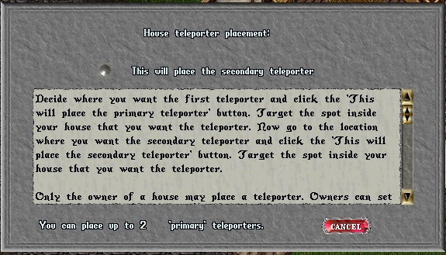

Go to the location you want the secondary teleporter to be placed. Click the button to place it, target the location and, assuming you have targeted inside the house boundaries of a house you own, the teleporter will be placed and you are done.

The house teleporter functions menu

Double-clicking on a teleporter will bring up a gump that has three functions that you can perform, Rename the teleporter, Set access level, and Remove the teleporter.
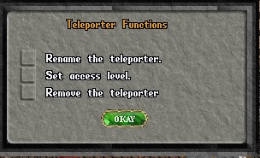

If you click on the checkbox next to Rename the teleporter and then click the OKAY button, you will receive a gump to enter a name. That gump is self explanatory.

If you click on the checkbox next to Set access level and click the OKAY button you will receive the following gump.
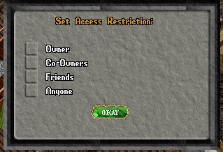

This allows you to restrict access to the teleporter to different levels of affiliates. Unlike secure containers, which allow affiliates above the affiliate level they are secured for, house teleporters are restricted to an affiliate level. Set the access to Friends and co-owners cannot use the teleporter. The only exception is house owners, who can use all teleporters regardless of access restrictions. By default newly placed teleporters are set to “Anyone”.

The Remove Teleporter option will present a confirmation gump asking if you want to remove the teleporter. Choosing this option will remove both teleporters, the origin and destination.

